**Analog Devices Inc. Phillpines**

**Machine Learning on the Edge: Hand Gesture Detection and Recognition using MAX78000**

**Mercano, Ivan Gil G.**

**A Practicum Report Submitted to the School of Information Technology**

**In Partial Fulfillment of the Requirements for the Degree Program**

**Bachelor of Science in Computer Science**

**Mapua University**

**September 2022**

**APPROVAL SHEET**

**Mapua Institute of Technology School**

**of Information Technology**

This is to certify that I/we have supervised the preparation and read the practicum report prepared by Mercano, Ivan Gil G. and that the said practicum has been submitted for final examination by the Oral Examination Committee.

____Mariel Tinaco____

Adviser/OJT Supervisor

As members of the Oral Examination committee, we certify that we have examined this practicum report, presented before the committee on ____, and hereby recommended that it be accepted as fulfillment of the practicum requirement for the degree in Program Bachelor of Science in Computer Science.

_________________________ ______________________

Panel Member Panel Member

This practicum report is hereby approved and accepted by the School of Information Technology as fulfillment of the practicum requirement for the degree in Program Bachelor of Science in Information Technology.

________________________

Ariel Kelly Balan

Dean, School of IT

**ACKNOWLEDGEMENTS**

The intern would like to thank everyone who contributed to the success of the internship program.

First, I would like to thank God for giving me this opportunity to learn and continue to grow and experience real life application of what I have learned in my course.

To my OJT adviser, John Paul Tomas, for guiding me in the proper procedures and requirements needed for the internship.

To my parents who continuously support whatever track or field I am currently interested in and for the continuous love and support they gave me.

To my co-interns and batch mates in the department who helped me grow in many ways.

My supervisors, Mariel Tinaco and Louijie Compo, in teaching and guiding me throughout my internship. They provided the best learning environment and training plan for me to grow and explore the current market and corporate settings of my future career.

And lastly, the managers of the department, Mr. Glen Amparo, and Johann Ignacio for letting me stay in the department and giving me valuable teachings from life experiences.

**ABSTRACT**

This document indicates the training experiences and learnings the intern acquires during the on-the-job training program in Analog Devices Inc. (Gen Trias). The document includes the history and profile of the company and its mission and vision. Furthermore, the document also includes the documentation of the project of the intern which serves as his main activity and contribution to the said company. The project documentation consists of overview of the project, statement of the problem and objective, significance, and the brief methodology of the project.

**TABLE OF CONTENTS**

|  |  |
| --- | --- |
| Title Page | 1 |
| Approval Sheet | 2 |
| Acknowledgements | 3 |
| Abstract of the Project | 4 |
| Table of Contents | 5 |
| List of Figures | 6 |
| Certificate of Completion | 7 |
| Company Profile  Chapter 1 |  |
| Company History | 8 |
| Company Mission and Vision | 8 |
| Chapter 2 |  |
| Trainee |  |
| Specific Department Where the Trainee Assigned | 9 |
| Duties and Responsibilities | 9 |
| Training with Your Company | 10 |
| Learnings Acquired from the Training | 11 |
| Corporate Learning | 11 |
| Technical Learning | 12 |
| Assessment and Evaluation on the Company | 12 |
| Career Path Assessment | 12 |
| Chapter 3  Project |  |
| Project Overview/Description | 13 |
| Problem/Opportunities Statement | 14 |
| Objectives Statement | 14 |
| Significance | 14 |
| Scope and Limitations | 15 |
| Brief Methodology | 15 |
| Proof of Output  Screenshots  Diagram/Flowcharts | 17-19  20 |
| Appendices |  |
| Resume | 21-23 |
| Project Approval Form | 24 |
| Accomplishment Reports | 25-27 |

**LIST OF FIGURES**

|  |  |
| --- | --- |
| Figure 1.1 MAX78000 Microcontrollers | 13 |
| Figure 3.1 Dataset Used | 17 |
| Figure 3.2 Model Training Graph (Tensorboard) | 18 |
| Figure 3.3 Training and Validation Accuracy | 18 |
| Figure 3.4 Successfully Detected and Recognized Hand Gestures | 19 |
| Figure 3.5 Unsuccessful Detection and Recognition of Hand Gestures | 19 |
| Figure 3.6 Data Acquisition Flow Chart | 20 |
| Figure 3.7 CNN Model for Hand Gesture Detection and Recognition | 20 |

**CERTIFICATE OF OJT COMPLETION**

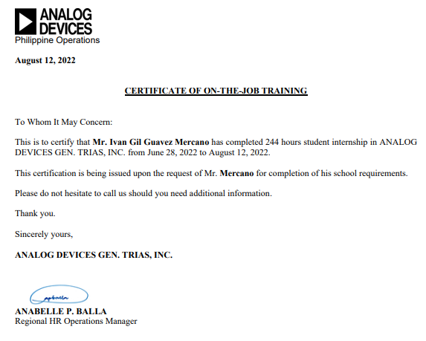

**CHAPTER 1**

**Company History**

The company was founded by Ray Stata and Matthew Lorber in 1965 upon graduating from engineering program at Massachusetts Institute of Technology. The two founder meets when Stata was hired by Hewlett-Packard (founder of HP) in Cambridge, Massachusetts, where he shared the apartment with his batchmate Matthew Lorber.

Since then, the company grows larger, designing and manufacturing analog, mixed signal, and DSP integrated circuits. Today, Analog Devices intend to become the leading company in the Artificial Intelligence and Machine Learning field, providing innovative solutions to improve quality of life and today’s engineering problems.

**Company Mission and Vision**

**ADI’s Mission**

Analog Devices mission is to be the world’s best signal processing company

**ADI’s Vision**

Analog Devices is dedicated to enriching people s lives through signal processing technologies. We transform people s experience with technology by bridging the analog and digital worlds.

**CHAPTER 2**

**Specific Department Where the Trainee Assigned**

After the orientation week, the intern was assigned to the NTI System Integration Engineering (Applications) of Analog Devices Gen Trias. The department is generally responsible for developing and researching applications for the company’s product. One example of this is the project of the intern where he implemented a CNN model to a microcontroller to detect and recognize hand gestures.

**Duties and Responsibilities**

The intern’s responsibility was the same to the employees’ normal duties. The only difference is that the intern has a buddy or superior that is helping him to work. In ADI, the intern were challenged to participate in the real project of the company. The superior will require the interns to come up with a unique way to apply the current project to solve a real-world problem. One example of this the time-of-flight camera product of ADI, as an application for this product, the interns come up with an application where the user will be able to 3d print any object that is scanned using the camera.

**Training with Your Company**

In the orientation, the supervisor pointed out that aside from learning how a semiconductor company operates, the intern should be able to apply what he/she have learned in the university to create an invention or an application base on his/her interest. In my case who have a specialization in Data Science, my interest falls onto apply machine learning on edge devices. But first, the intern should be familiarized first on how a team operates in creating a project. One of the basic requirements in working as a team is having a version control system, to address this, the company use private Github repository where the employees can view, save, and edit their current work. This tool also allows developers to merge their work efficiently without having code conflicts.

|  |  |  |
| --- | --- | --- |
| **Commonly Used Github Commands in the Workplace** | | |
| **Initialization** | **Commits** | **Branch** |
| Git init <directory> | Git add <path> | Git checkout <branch> |
| Git clone <url> | Git restore –staged <path> | Git checkout -b <name> |
| Git config user.name “username” | Git commit -m “message” | Git branch |
| Git config user.email “email” | Git status |  |
|  | Git push <remote> <branch> |  |
|  | Git pull -r |  |

For the third and fourth week of the internship, the interns focused on familiarization in python language. This is important since 90% of work in the department use this language. Another tool the interns used is Pytest, this tool allows the developer to test the code if there are any hidden errors or bugs that can be problematic when project is deployed to the consumers.

Lastly, the interns were familiarized how to build, install, and use SDK. For me, I personally got challenged in this training since this topic is new to me. The SDK I built is for the edge device that I will going to use for my machine learning project for the company, which requires a lot of image processing imports and environment path calibration.

**Learnings Acquired from the Training**

The intern learned a lot, from applying the knowledge he learned from the university to gaining real life experience on how a company operates. One of the most notable learnings the I personally acquired that I think I would use in my future career is by not being to reliant on others. In the company I learn how to learn by myself, I learned how to explore things and know what I don’t currently know. Here, I realized that learning never stops, that the people around and the environment itself promotes the growth of an individual.

**Corporate Learning**

The intern learned how employees operates on a regular basis. In the company the intern learned how important a team is and how a team should be at the same page all the time. This on-the-job training gave me an insight on what to expect when I really stepped out and find a job myself. I am certain that these learnings I have acquired from my internship would be helpful for my future career.

**Technical Learning**

For the technical learning, the intern learned advance use and application of python. The intern also learned how to use different tools in developing software and application such as GitHub, PyTest, SDK building, etc. Lastly, the intern gained more insight on Machine Learning specially on how it can be implemented or applied to solve an existing problem.

**Assessment and Evaluation on the Company**

The assessment and evaluation of the company to the intern consist of three notable insights. The first on how the intern able to adapt quickly and adjust the learning he currently has. The second is on how willing the intern to learn what ever topic he didn’t currently know. And lastly how the intern handle project under pressure, during the internship, the intern usually have a daily deadline or report where he need to accomplish, this report pushed the intern to be composed and time efficient.

**Career Path Assessment**

The career path of the intern in the company focused on software development side. Since the company that the intern get into focuses more on hardware, the department head gets an idea on the current needs in software development team side of the company. The supervisor also recommended for the intern to pursue machine learning since this market new and have a potential to grow more in the future years.

**CHAPTER 3**

**Project Overview/Description**

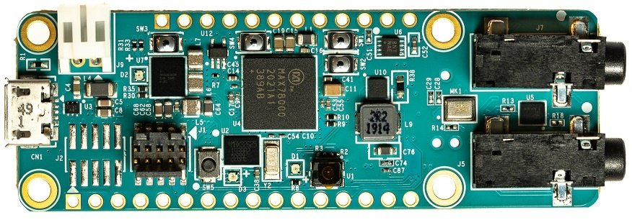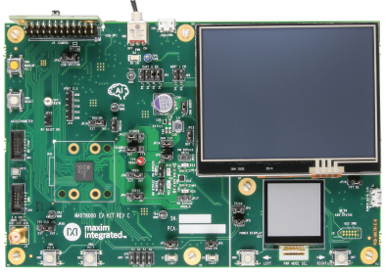The project utilizes one of the current products of the company. This product is a microcontroller called MAX78000. This microcontroller has a CNN accelerator, allowing it to collect and process data in real time.

MAX78000fthr MAX78000evkit

The intern deployed a CNN model in the microcontroller to detect and recognize hand gestures when the user captures an image using the camera integrated in the microcontroller. The supervisor came up with this project to have a proper documentation on how to explore and implement own personalized model to the unit. According to the department, they still haven’t tested the full capability of the microcontroller, that’s why it would be a great help and a challenge to make this project.

**Problem/Opportunities Statement**

The problem/opportunity of the project include:

* What are the necessary steps in implementing own model to the microcontroller?
* What are the bottlenecks in implementing the model?
* What are the current threshold and capability of the microcontroller?
* What is the most efficient model design to detect and recognize hand gestures?

**Objective Statement**

* To know if a personalized created model can be implemented to the microcontroller.
* To know the full capability of the microcontroller
* To know if there are any bottlenecks in implementing own model
* To detect and recognize hand gestures

**Significance**

The project will be beneficial to the follow:

**Company** - as it will serve as a foot hold as a documentation in creating and deploying own model to the microcontroller.

**Future Intern –** as this project will serve as a starting line for those who want to venture machine learning in edge devices using max78000

**Current Intern –** as this project widen the knowledge of the intern in the field of edge devices and machine learning implementation.

**Scope and Limitations**

This project is limited in developing and deploying CNN model to the MAX78000 microcontroller. This project will only recognize and detect simple and common hand gestures such as fist, open palm, peace, palm, three, one, thumb, pinky, okay, four, and satan. The project will be developed using python language and the CNN model will be implemented to the microcontroller using C language.

**Brief Methodology**

To the start with, the intern should familiarize with the pipeline of the max78000, so for the first week of the project, the intern focuses on getting used to in using the pipeline by trying the prebuilt model in the SDK. For the second week, the intern focuses on acquiring the right dataset for the project. The dataset that is used for the project is acquired from Kaggle, this dataset pass both qualification for the project where the gesture should have solid background and consist of multiple hand gestures with variations. After acquiring the dataset, the intern then created a data loader for the dataset to be loaded to the model for the training. The intern also created his own personalized stratified sampling algorithm since the SDK doesn’t support libraries used in stratified sampling. After creating the data loader, the intern then proceeds in creating the right model for the data. The model consists of six 2-dimensional convolutional network, one dense layer, and one linear layer. After preparing model, the intern then created its own shell scripts files to train the data. During the training, the intern then changed some optimizer to have a better training and validation results. After the training, the model will then be flashed to the microcontroller where the intern will need to modify the generated C code for the microcontroller to capture images that will be loaded to data in order to predict the classes. After flashing the model to the microcontroller, the user will then validate what the model yields using data that will be captured by the microcontroller’s camera. After verifying the results and validity of the model, the intern then proceeds with the documentation of the process and results of the project.

**PROOF OF OUTPUT**

**Screenshots**

|  |  |  |
| --- | --- | --- |
|  |  |  |
|  |  |  |
|  |  |  |
|  |  |  |
| Figure 3.1 Dataset Used | | |

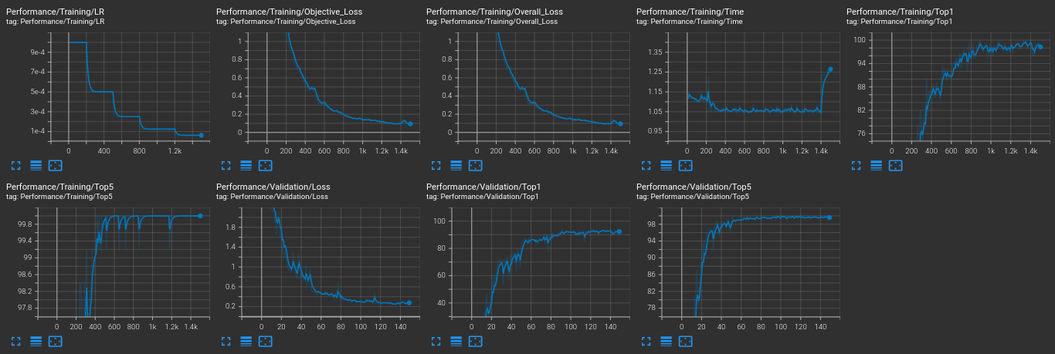

Figure 3.2 Model Training Graph (Tensorboard)

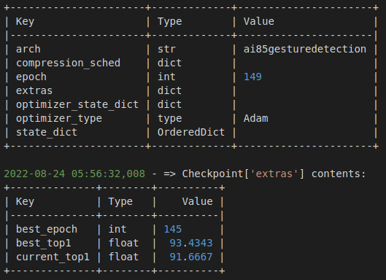

Figure 3.3 Training and Validation Accuracy

|  |  |  |
| --- | --- | --- |
|  |  |  |
|  |  |  |
|  |  |  |
| Figure 3.4 Successfully Detected and Recognized Hand Gestures | | |
|  |  |  |
| Figure 3.5 Unsuccessful Detection and Recognition of Hand Gesture | | |

**Diagram/Flowcharts**

Figure 3.6 Data Acquisition

Figure 3.7 CNN Model for Hand Gesture Detection and Recognition

**APPENDICES**

**Resume**

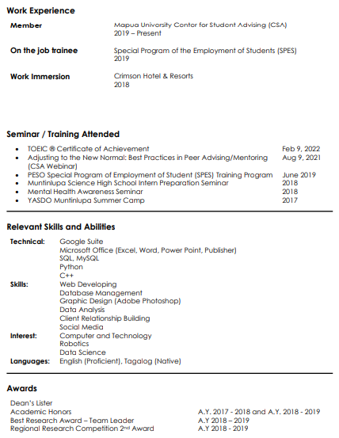

**Project Approval Form**

**ACCOMPLISHMENT REPORTS**



